

**User guide**

Created by Ilse A. Rasmussen & Allan Leck Jensen

27 August 2013

**User guide for Organic Eprints**

This user guide/manual is a collection of screenshots from Organic Eprints ([www.orgprints.org](http://www.orgprints.org)) with instructions how to use the archive. The guide goes through different options of how to register, browse, search, save searches and deposit documents by showing screen shots with short, instructive comments.

**Contents**

**Home 3**

**Register 4**

Modify profile 6

New email address......................................................................................................... 7

**Forgotten password? Reset password 8**

**Browse 10**

**Search 14**

**Saved searches** **17**

**Deposit paper 19**

Eprint type 20

Document information 21

Subjects 23

Research affiliation 24

Upload 25

Restricted access 26

Additional documents 27

FP7-funded projects 28

Deposit agreement 28

Preview 29

**Eprint types 31**

**Make a new version of an eprint 33**

**Make a copy of an eprint 36**

**Home**

**This page:** Contains Welcome, with link to more information about the archive, Browse and Search in very simple versions and Register, where you can create an account.

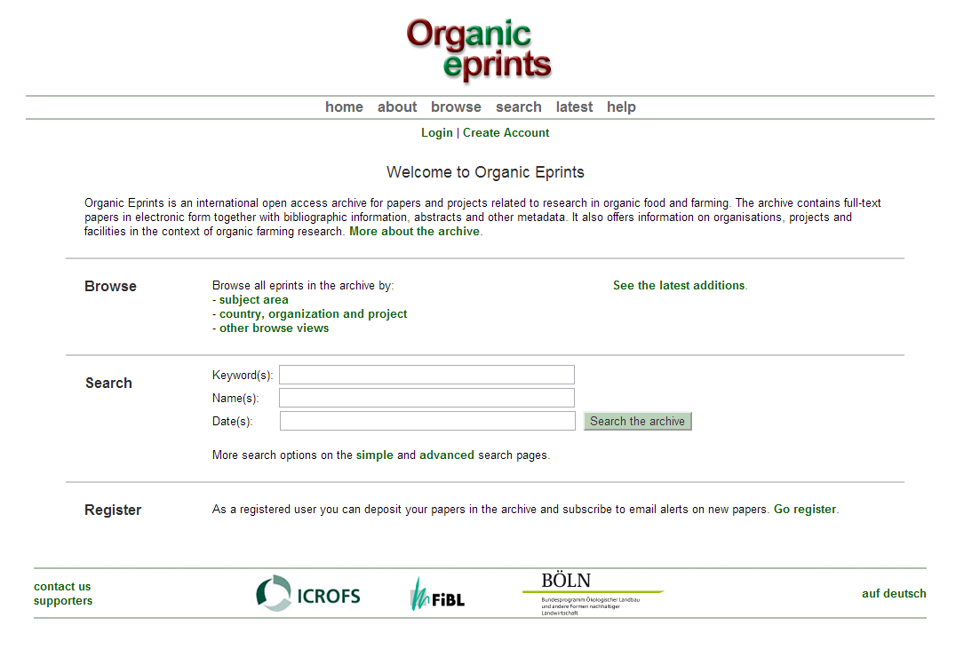

This header is common for all Organic Eprints pages

[About](http://orgprints.org/about.html): information about Organic Eprints, including policy, background and support, open access and copyright issues, statistics and software.  
[Browse](http://orgprints.org/browse.html): described in section on Browse.  
[Search](http://orgprints.org/cgi/search/simple): described in section on Search.  
[Latest](http://orgprints.org/cgi/latest): the eprints accepted into Organic Eprints within the last week.

[Help](http://orgprints.org/help/)**:** the help pages for Organic Eprints.

At the bottom of the page, you can find information about the partners and national editors.



You can also switch the language to German.

**How to become a registered user of Organic Eprints**

Go the the Organic Eprints homepage at <http://www.orgprints.org/>

*Click "Create Account"*

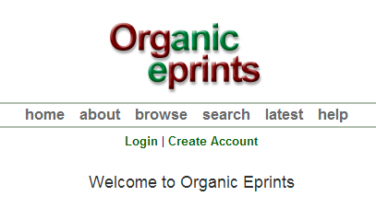

*Fill in the information. Required field are marked with a star:* 

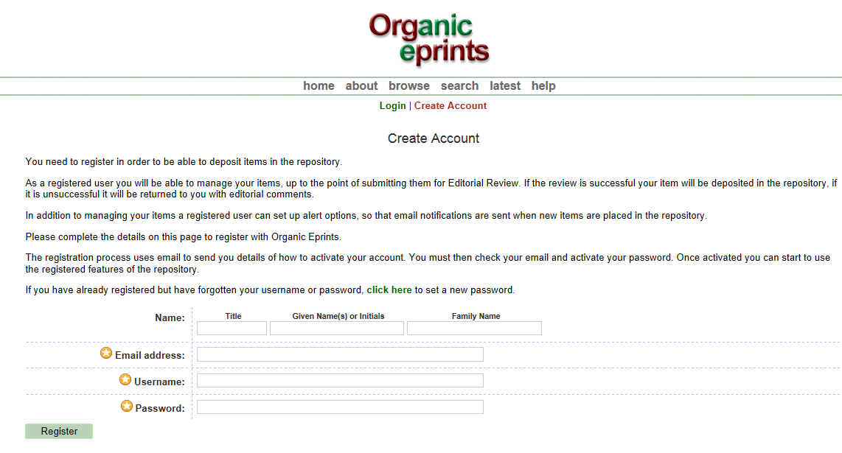

*Click ”Register” and the screen will look like this:*

**

*Click on the link ”Activate your password” in the email you receive:*

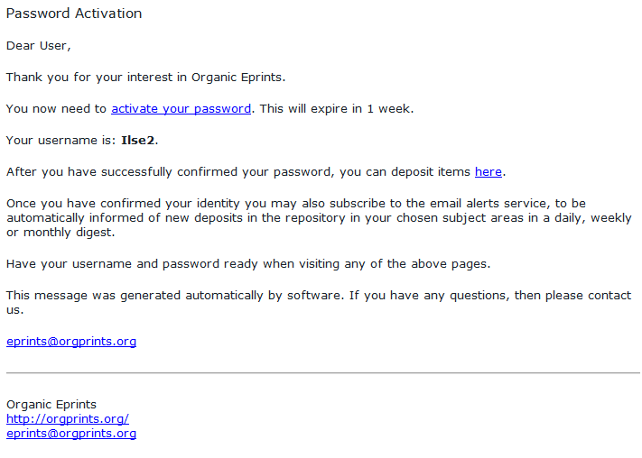

**How to modify your profile**

*Once you are logged in to Organic Eprints, the top of the pages will look like this:*

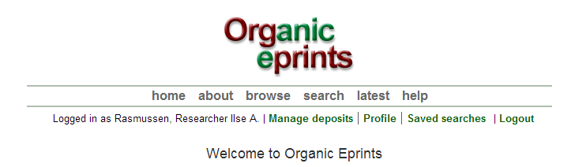

Click on "Profile" to see the details about your profile.

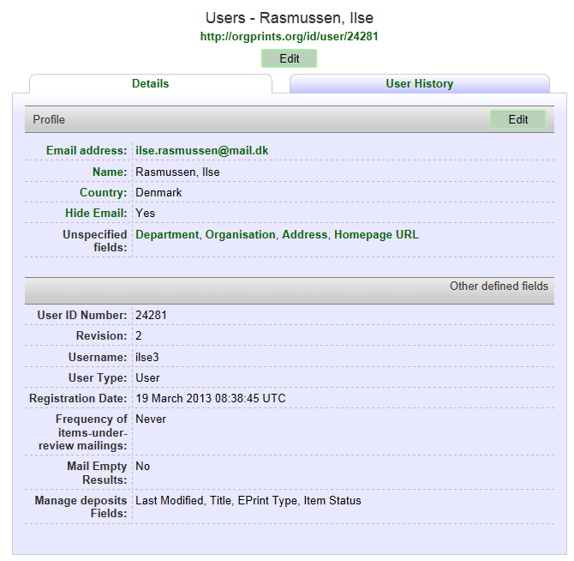

Click on ’Edit’ to edit your account information.

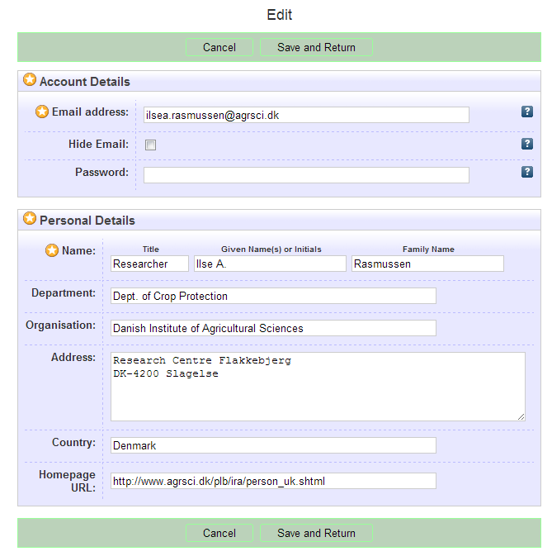

Leaving this field blank will not affect your password. To change password, type a new one and click "Save and Return".

Remember to click "Save", when you are finished.

If you change email address, also use ‘Edit profile’ for this. Simply type in your new email address and click ’Save and Return’.

**Reset password in Organic Eprints**

If you have forgotten password or username

*On "Home" in Organic Eprints, click "Login"*

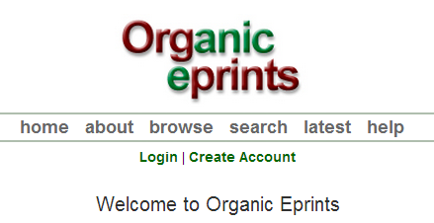

*When you reach the login page, click "Reset"*

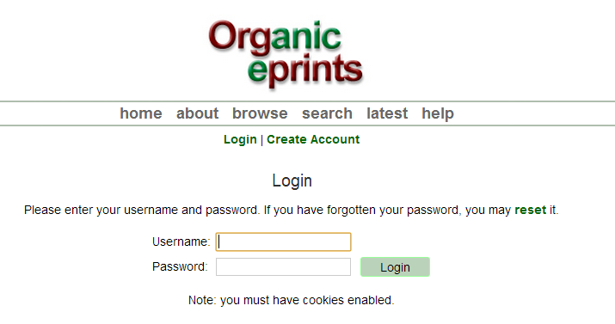

*On the next page, enter your email-address and a new password, then click submit:*

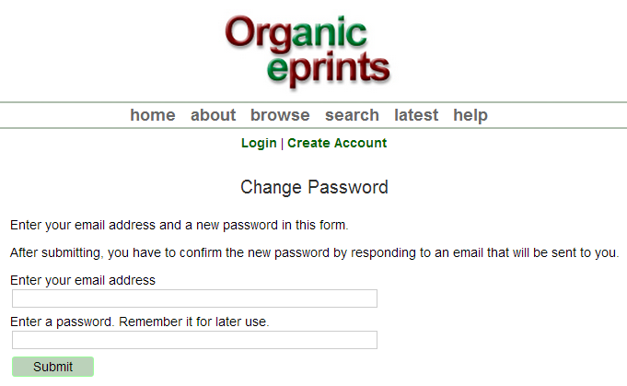

*Confirm the new password by responding to the email sent to your email address.*

**Browse**

You can browse the eprints of the archive by selecting a category and then going deeper and deeper into the hierarchy of categories.

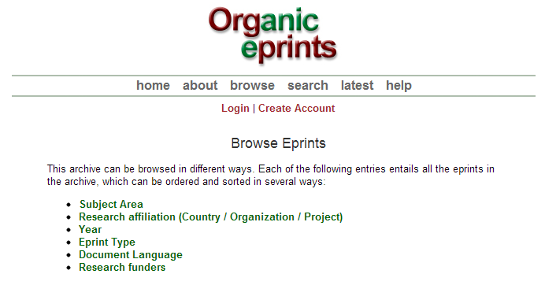

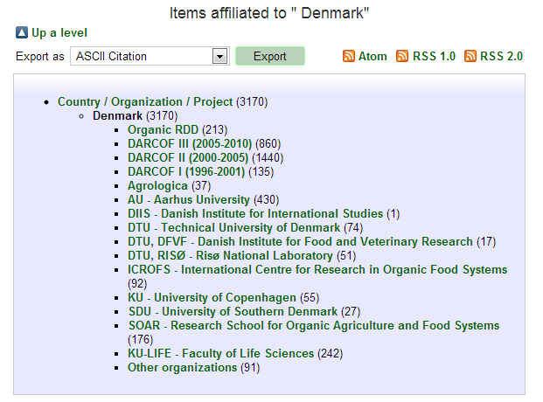

In this example we have chosen "Research affiliation", then "Denmark" and finally "DARCOF III", which ends up showing a list of all the DARCOF III projects.

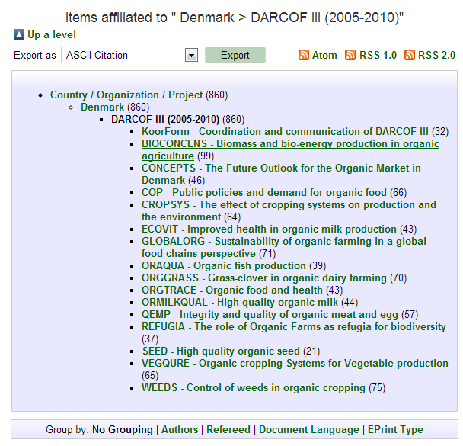

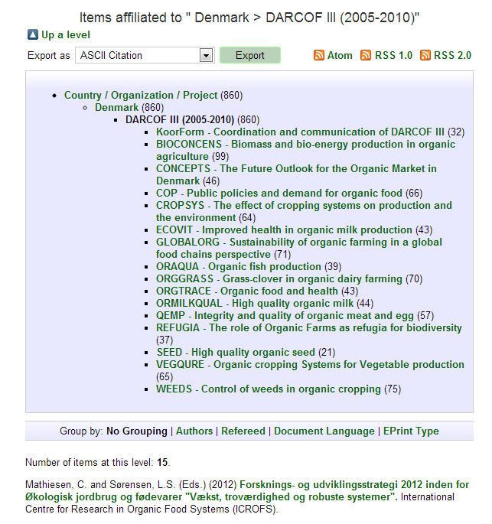

Choices of which criteria to sort the list by

Click the title of the eprint to see more about the document

Subscribe to RSS-feeds of this list

Export the list in different formats

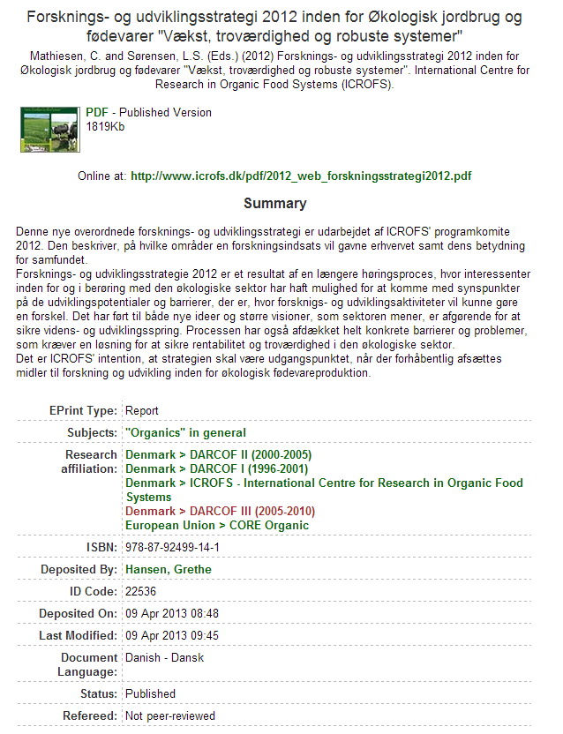

**Search**

**Very simple search**

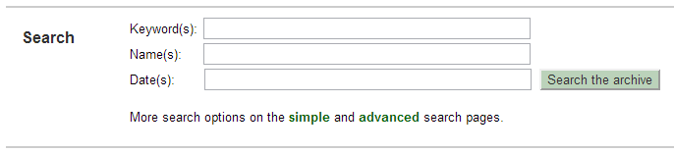

From the Home page, you can carry out a very simple search: Simply type keyword(s), name(s) and/or date(s) in the boxes and click "Search the archive".

For more options, use "Simple" or "Advanced" search.

The current version of Organic Eprints does not support the use of all special characters, such as diacritics. If you use special characters, and the text looks strange, please write to [eprints@orgprints.org](mailto:eprints@orgprints.org) to enquire about the characters.

**Simple search**

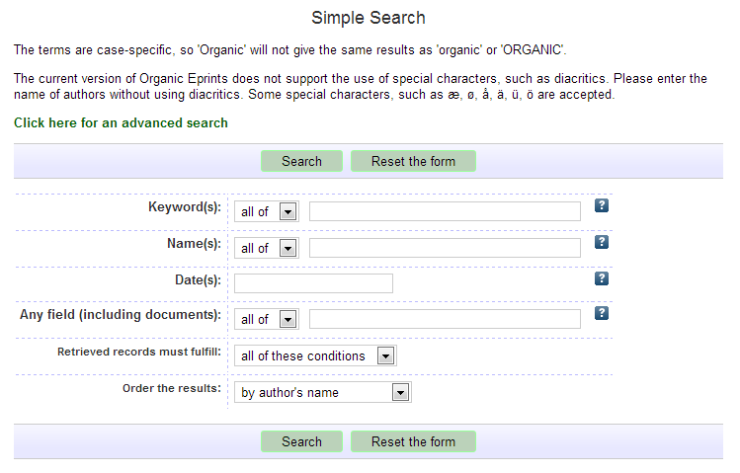

By clicking a question mark, you expand the explanation as shown below

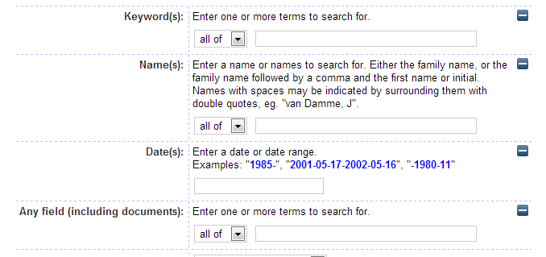



Choose whether the search should include only documents, which fulfil all of the conditions above, or all documents, which fulfil any one of the conditions.

Choose whether the search should include only documents, which contain all of the search terms, or all documents, which contain any one of the search terms

**Advanced search**

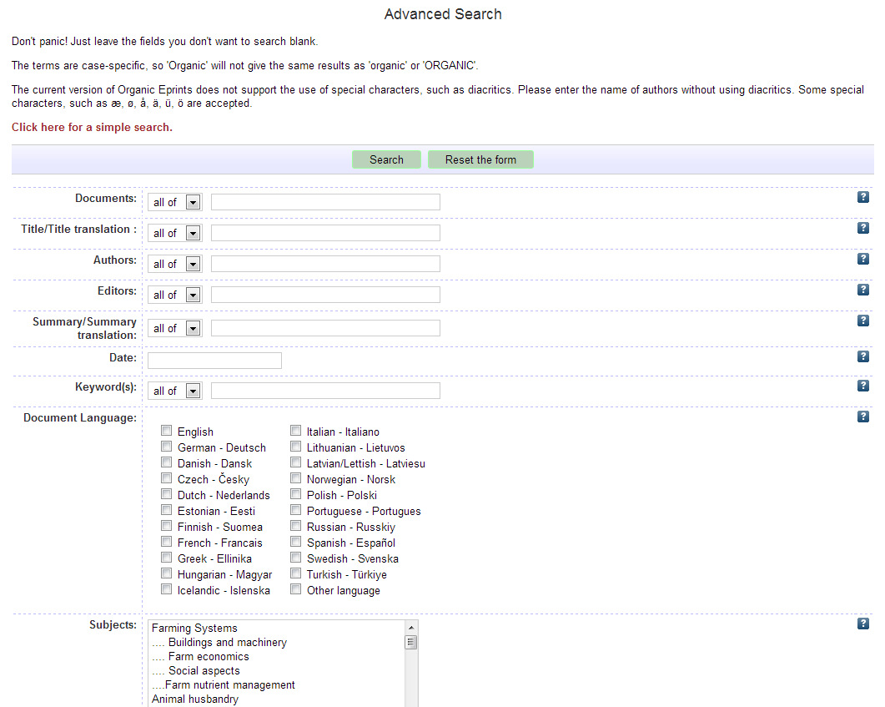

Select the value(s) you wish to search for. If no box is ticked, the system will retrieve eprints with any value in this field (i.e. not use that field to find eprints).

Lists or roll-down menus. You can select one or more values. Select consecutive values by marking the first item, pressing the CAPS button and then marking the last item. Select non-consecutive values by marking each item while holding down the CTRL button. If no value in the list or menu is selected, the system will not use that field to find eprints

**Saved searches**

When you are logged in and have made a search, you can save the search. Your saved searches can be viewed by clicking “Saved searches” in the personal menu bar. The results of a saved search will be updated when new documents are deposited. In this way, you can follow the development within a particular topic. You can also set up Organic Eprints to send you a scheduled email with the results of your saved search.

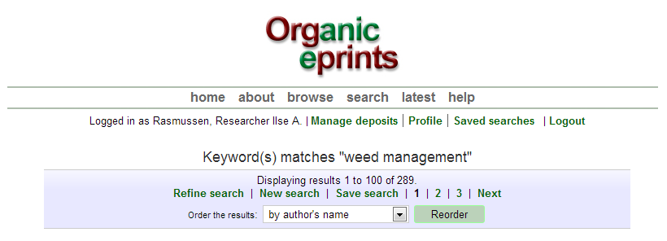

*Click "Save search"*

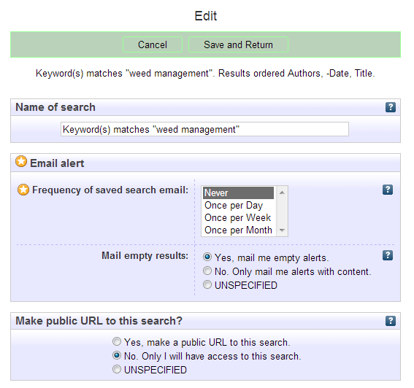

Correct the Name of the search if necessary.

Choose how often to receive an alert, and whether to receive empty alerts.

Choose if you want to make a public URL to the search (e.g. for a website).

Make sure you click "Save and Return".

**Deposit a paper in Organic Eprints**

*If you’re not already a registered user, please register by creating an account, otherwise login. Read about this in an earlier section.*

*After login you can select the "Manage deposits" page on the personal menu bar, then click "New item":*

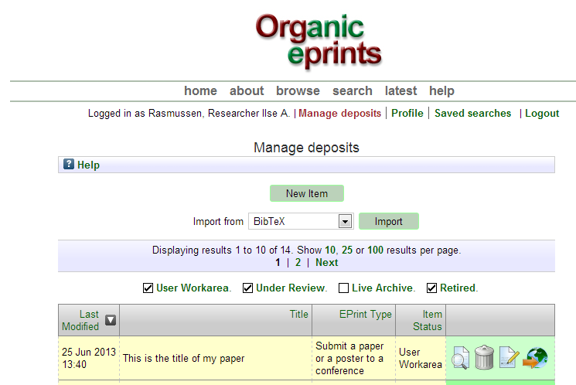

*The Eprint information is divided into stages. The first stage is Type, where you have to choose "Eprint type" (see Eprint types later in this manual), then click "Next".*

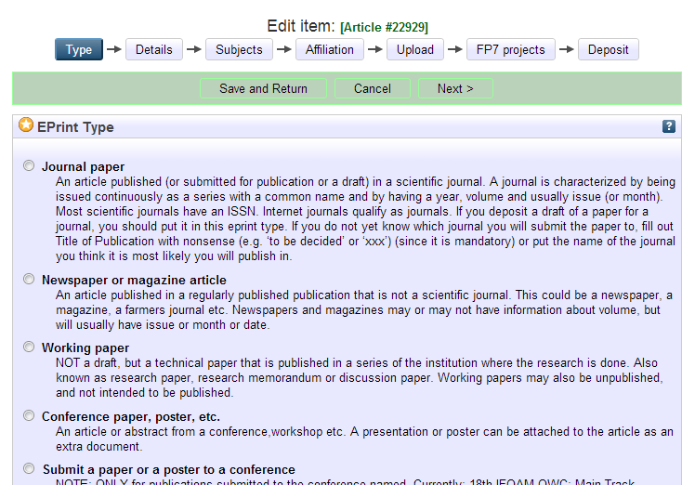

*In the second stage, Details, there is a lot of required and optional information. The required information is marked with a star:* 

*Enter the title of your paper as it appears on the first page. Enter additional information (this differs between eprint types)*

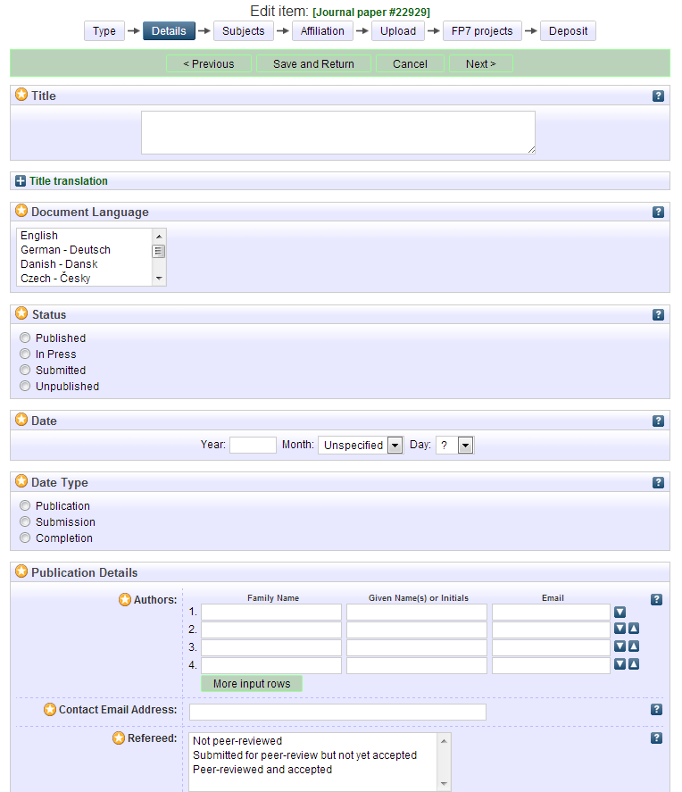

Only year is compulsory

Your email address will not be publicly visible, but used so that anyone interested can "Request a copy" (for papers with restricted access)

The current version of Organic Eprints does not support the use of all special characters, such as diacritics. If you use special characters, and the text looks strange, please write to [eprints@orgprints.org](mailto:eprints@orgprints.org) to enquire about the characters.

*Still in the second stage, Details, enter additional information (this differs between eprint types)*

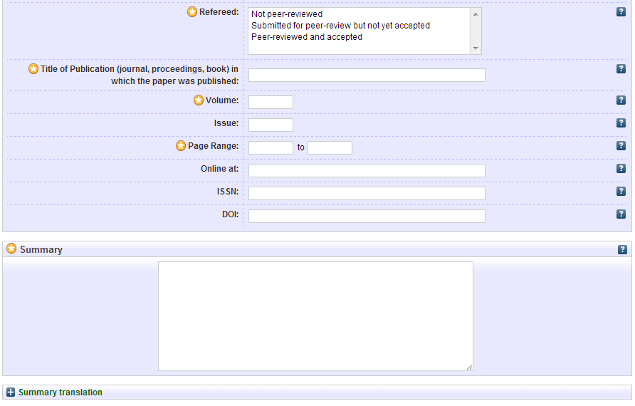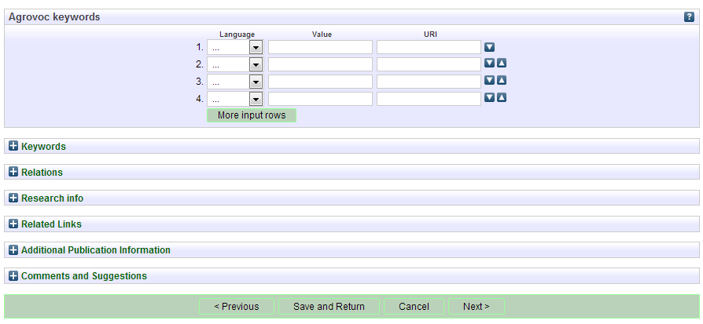

Agrovoc keywords are controlled agricultural keywords, that are intended to make it possible to search across different languages.

If you’re depositing a draft, write 0

DO NOT WRITE THE TITLE OF YOUR PAPER HERE!

The title of the journal, your paper is published in. If you’re depositing a draft, write e.g. ’To be decided’ or ’xxx’

*Click "Next".*

*In the third stage, Subjects, you are supposed to add relevant subjects by expanding the trees (click the ’+’) and clicking "Add".*

*Do not add more than 3-4 subjects.*

*Do not add the "trunk" (e.g. Farming Systems") AND a "branch" (e.g. Farm economics), as the "trunk" will appear together with the branch.*

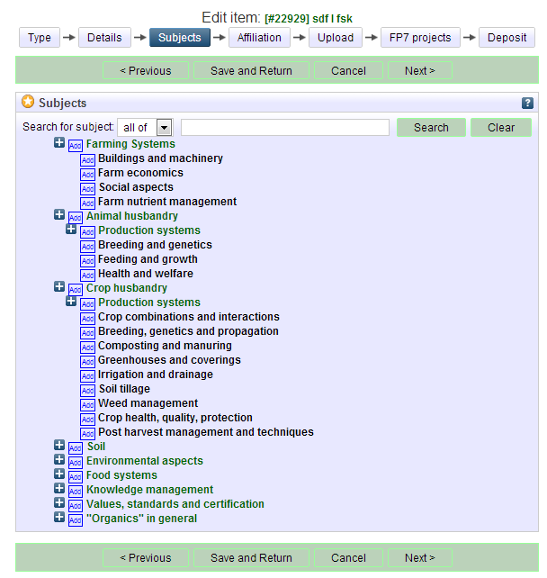

*Click "Next"*

*In the fourth stage, Affiliation, add your own affiliations, e.g. project, organization etc.*

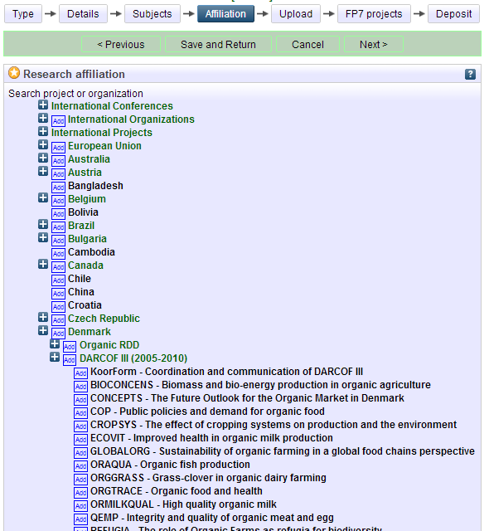

*Click "Next"*

*In the fifth stage, Upload, you transfer a copy of the publication to Organic Eprint. First, give your paper file a relevant name.*

**Important**

File names should follow some rules. This includes:

* Do not use special characters in the file name (e.g. blanks, accents, ü, ø etc.)
* Choose a clear name for your file, preferably following the format "authorname_year_keyword.doc"

*Click "Choose File" to find your file on your computer’s file system, and then click "Next".*

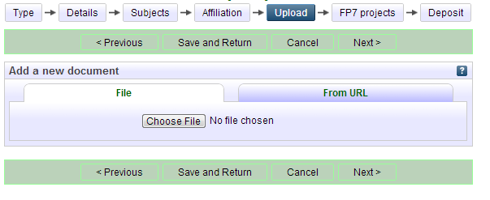

*After upload, correct metadata and click "Update Metadata"*

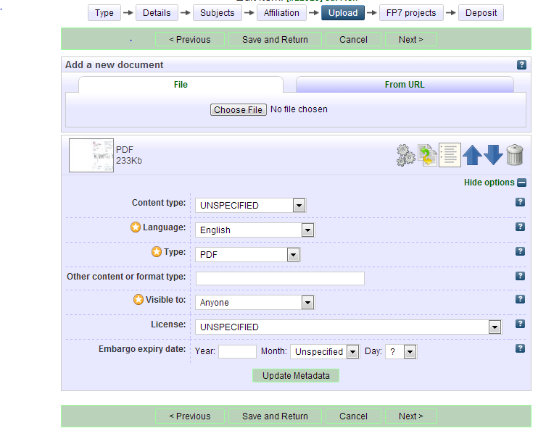

* **Visible to**: allows you to choose the level of access restriction for this document. Please select as open access as possible. The categories are:
  + **Anyone**: means access for anyone with internet access (default).
  + **Registered users**: access only for registered users at Organic Eprints (there are currently over 15.000 registered users, so this should not be used as a way to strictly limit access)
  + **Depositor and staff only**: access only for yourself and the archive staff. This is useful for papers with copyright requirements (see information about copyright at <http://orgprints.org/openaccess.html>). Other users will see the information entered for the eprint (e.g. title, authors, summary), but will not be able to open the files attached. Official evaluators can be granted access to all the publications from specific organizations upon agreement with these organizations. You can also use this option for any additional source files that are archived only for your own future use.
* **License**: Specifies an explicit license for this document (does not affect the access rights you grant). This repository allows Creative Commons licenses. Leave unspecified if this does not apply.
* **Embargo expiry date**: The date that a publisher- or sponsor-imposed embargo expires. On and after this date, this document will be made publicly accessible. Examples: 2015 - document made publicly accessible on 1st January 2015; 2015 June - document made publicly accessible on 1st June 2015; 2015 June 15 – document made publicly accessible on 15 June 2015.

*If you want, you can upload additional material (data, figures, poster or presentation):*

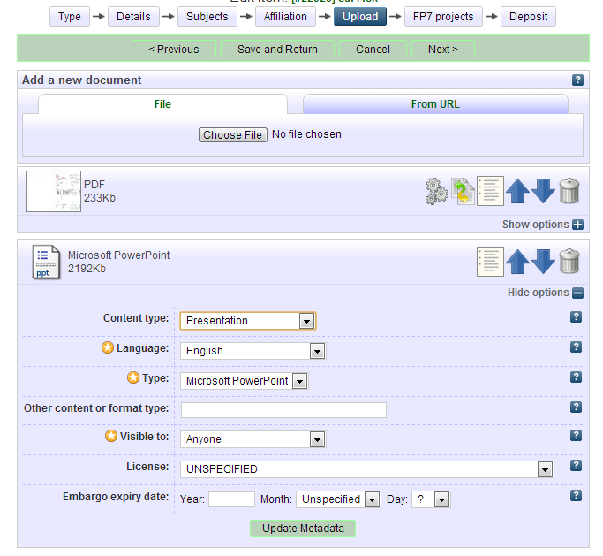

*Don’t forget to update metadata for the new document!*

*Click "Next".*

*If your eprint IS NOT part of an EU FP7-funded project, you can skip this page (no is default). The access rights you set previously on the upload page will not be affected.*

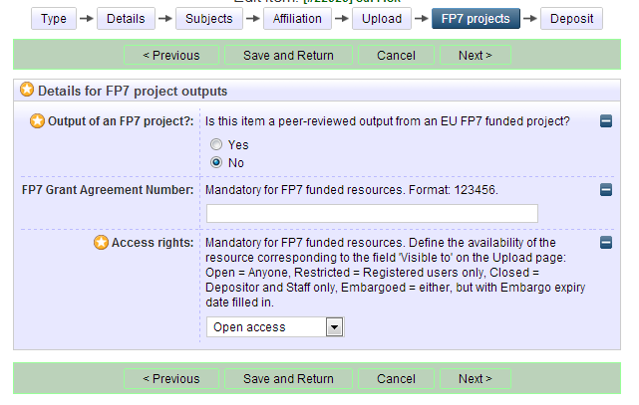*If your eprint IS part of an EU FP7-funded project, fill this page out. The FP7 Grant Agreement Number is also termed the Project Reference (i.e. in CORDIS).*

*Click "Next".*

*The final stage is Deposit. Read the Deposit Agreement, and deposit your paper or save it for later.*

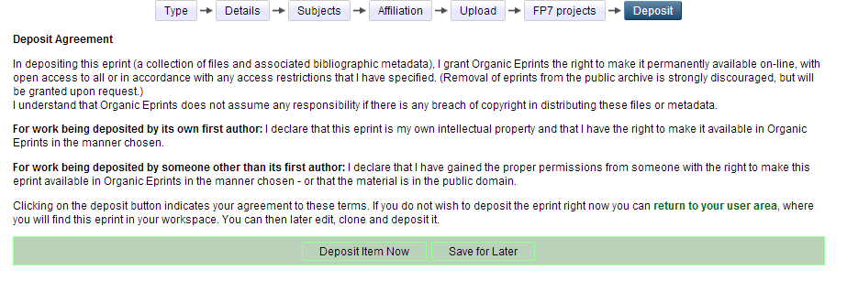

Please note, that the eprint will be edited by the archive staff before it becomes visible. Depending on workload, this may take from a couple of days to a couple of weeks.

*If you choose "Save for later", you can see a preview and edit if needed (in the Details stage).*

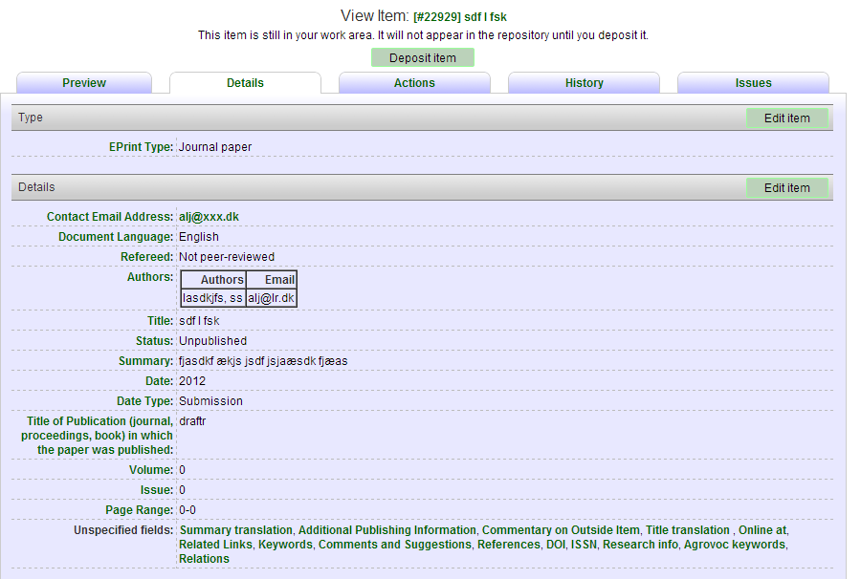

*If you log out of Organic Eprints without depositing your paper, you’ll find it under "Manage deposits" later*

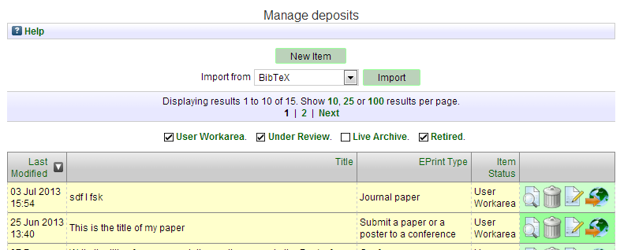

*You can then edit it and deposit it.*

**Eprint types**

This fact sheet describes the different eprint types to help you choose the correct type for every eprint.

**Journal paper:** an article published (or submitted for publication or a draft) in a scientific journal – that is, not newspapers, farmers magazines etc. A journal is characterized by being issued continuously as a series with a common name and by having a year, volume and usually issue (or month). Most scientific journals have an ISSN consisting of 8 digits, two groups of 4 separated by a dash. Internet journals qualify as journals. While journals have publishers and editors, these are not part of the bibliographic information about a journal paper. Papers in journals may have a DOI (digital object identifier). If you deposit a draft of a paper for a journal, you should put it in this eprint type. If you do not yet know which journal you will submit the paper to, fill out Title of Publication with nonsense (e.g. ‘to be decided’ or ‘xxx’) (since it is mandatory) or put the name of the journal you think it is most likely you will publish in. Once you submit, and when the paper is finally published, you can then make the required changes (see "Make a new version of a document in Organic Eprints").

**Newspaper or magazine article:** an article published in a regularly published publication that is not a scientific journal. This could be a newspaper, a magazine, a farmer's journal etc. Newspapers and magazines may or may not have information about volume, but will usually have issue or month or date.

**Working paper:** a preliminary scientific or technical paper that is published in a series of the institution where the research is done. Also known as research paper, research memorandum or discussion paper. Working papers may also be unpublished, and not intended to be published. A working paper is **not a draft**. A draft for e.g. a journal paper should be put in the eprint type "Journal paper".

**Conference paper, poster etc. (unpublished or published):** an article or abstract or presentation or poster from a conference, workshop etc., that has not been published in proceedings or journals, but may be published on the website of the conference or the authors’ institution.

**or:** an article or abstract from a conference,workshop etc., that has been published in proceedings (papers published in journals would be journal articles). **Make sure to fill in the field "Title of publication" since this decides how the citation is shown!** A presentation or poster can be attached to the article as an extra document.

**Proceedings (unpublished or published):** a collection of material from a conference, workshop etc. that has not been published.

**or:** a collection of papers (which may or may not be peer reviewed) from a conference, symposium, workshop etc. that has been published.

**Please check the way the citation looks (tab: Preview) and edit it if there is excess or missing information!**

**Report:** a technical report, a working report, almost anything that is published without being a book. Is usually published by an Institution and has place of publication.

**Report chapter:** a contribution to a report, such as a chapter or section.

**Book:** a monography (the same authors are responsible for the whole book) or antology (editors have collected contributions from several authors and have edited them). Will often have an ISBN-code (10 or 13 digits). Will always have a publisher and place of publication.

**Book chapter:** Contribution to a book.

**Thesis:** A thesis or dissertation that forms the work that has awarded the author with a title. May be M.Sc., Ph.D., Eng.D. or other.

**Data set:** A collection of data in a structured form. Usually the basis of research results.

**Teaching ressource:** a ressource that can be utilized in teaching such as an interactive website, game etc. A compendium, set of notes or a presentation could also be a teaching ressource, if it is aimed at teaching.

**Web product:** Text published on the internet, such as blogs, wikis, text on websites etc.

**Video:**

**Audio:**

**Other:** this is for eprint types that do not fit in any of the other types, but not for drafts, as these should be put in the eprint type that they will belong to once submitted. It could be:

Booklet/flyer/pamphlet: a publication that is not a book or report and not a part of a series such as a journal, magazine or newspaper. Usually aimed at dissemination. Often quite short, usually published by an institution. Does usually not have volume, issue, maybe not even page numbers.

**Research Programme description:** Description of a part of a research programme in a certain subject area, or a full programme.

**Organization description: Description of an organization that carries out or is related to research in organic food and farming systems.**

**Project description: Description of a research project of relevance to organic food and farming systems.**

**Research facility description:** Description of a research facility, where research of relevance to organic food and farming systems is, has been or can be carried out.

**Make a new version of document already in Organic Eprints**

*If you’re not already a registered user, please register by creating an account, otherwise login. Read about this in an earlier section.*

*After login you can select the "Manage deposits" page on the personal menu bar. Make sure "Live archive" is checked and choose the relevant document by clicking "View item" icon.*

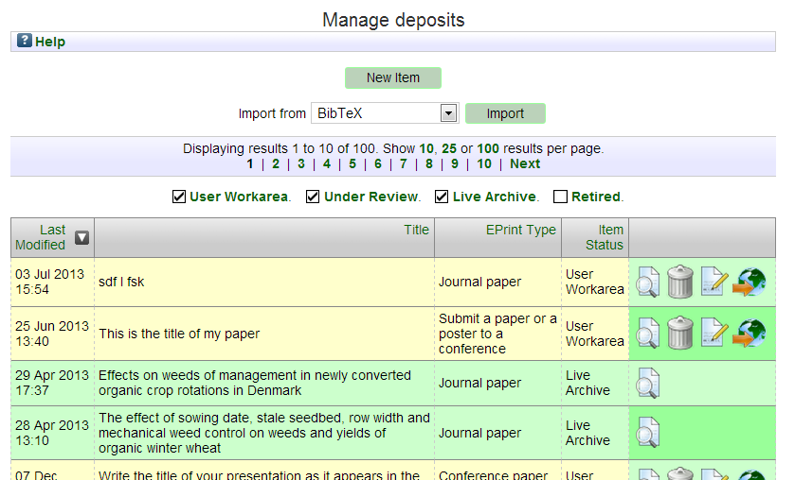

*Click the "Actions" tab*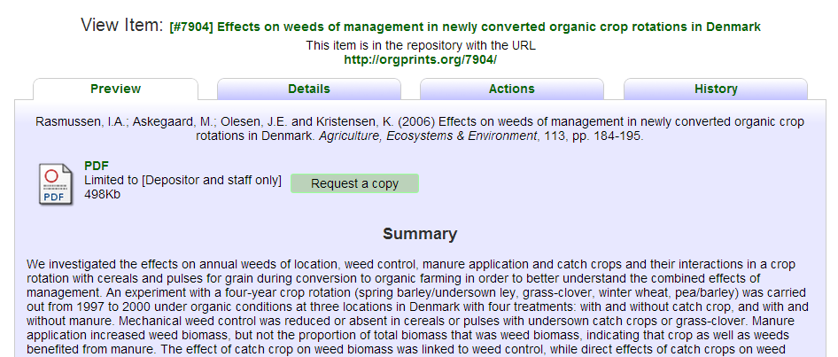

*Click "New version"* 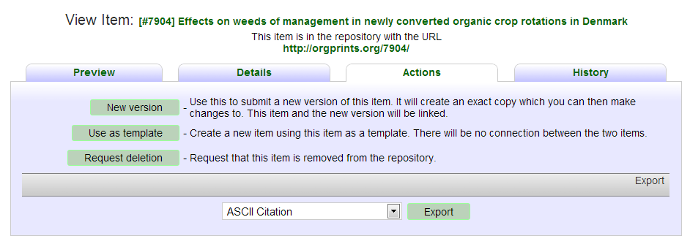

*You now have a new version of the item in your work area, where you can edit it.* 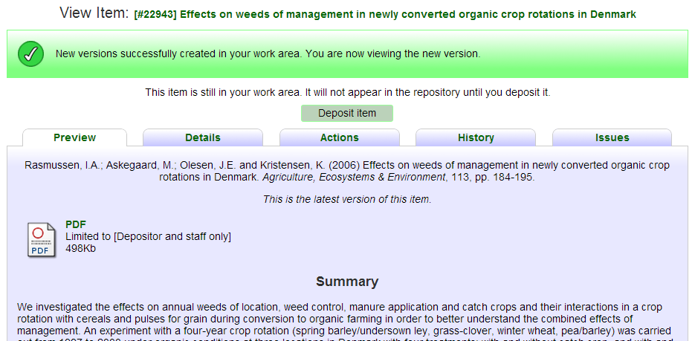

*Select the Details tab and click ‘Edit’ to edit the new version:*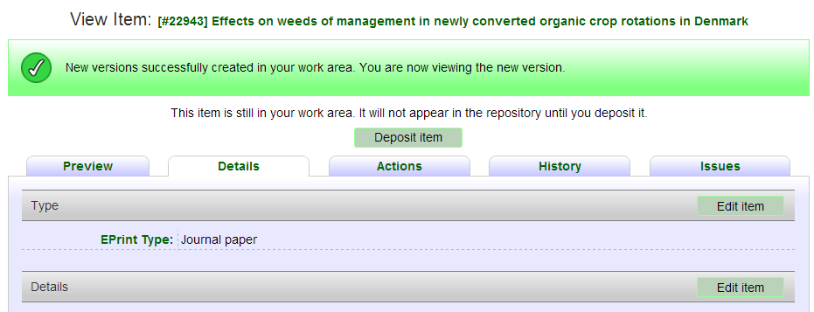

*Once you have edited and deposited the new version, and it has been placed in the live archive by the archive administration, the old version will appear with the text: "There is a more recent version of this item available" with a link to the most recent version.*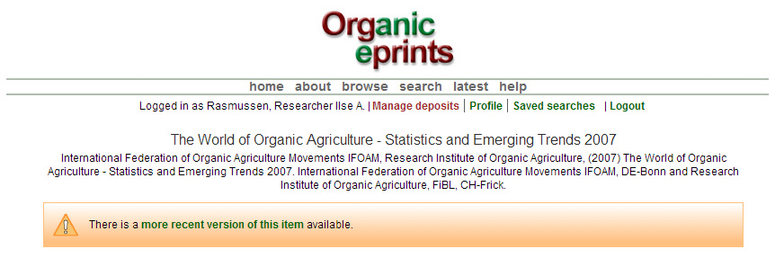

*At the bottom of the page, the different versions of the document will be shown:*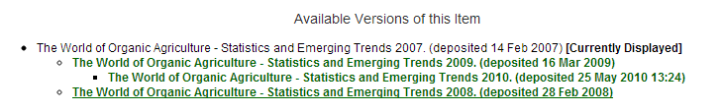

*In the most recent version, this is shown:*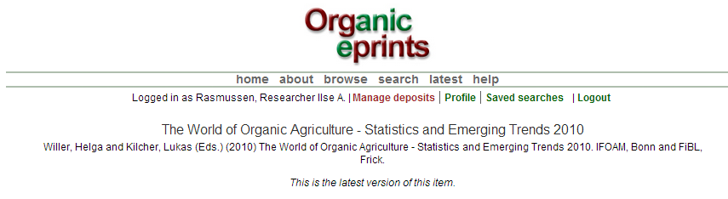

*The different versions are also shown at the bottom of that page.*

**Make a "copy" of document already in Organic Eprints**

**If you have several papers in the same conference proceedings or otherwise similar**

*If you’re not already a registered user, please register by creating an account, otherwise login. Read about this in an earlier section.*

*After login you can select the "Manage deposits" page on the personal menu bar. Make sure "Live archive" is checked and choose the relevant document by clicking "View item" icon.*



*Click the "Actions" tab*

*Click "Use as template"*

*You now have a copy of the item in your work area, where you can edit it.*

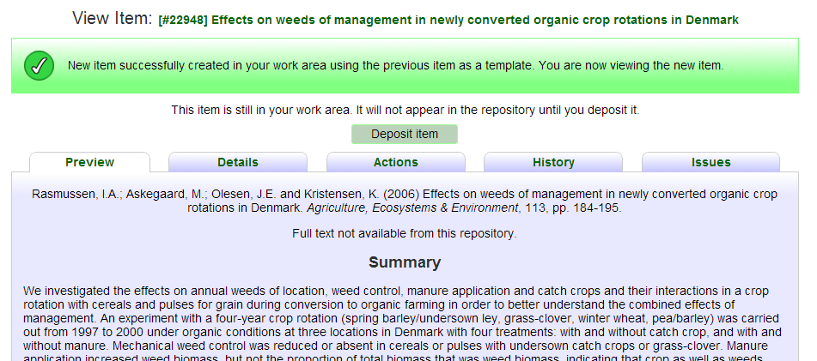

Please note, that if you make a copy, and then change the eprint type, information that belongs to the first eprint type, but not the new one, is retained, and will be shown. So be sure to delete any information not relevant to the new eprint type. Check by clicking "Preview" tab and see how the eprint looks and if there is any "wrong" information, especially at the bottom of the abstract page. If so, change to the original eprint type, delete the excess information, and change back to the correct eprint type. Check "Preview" again!